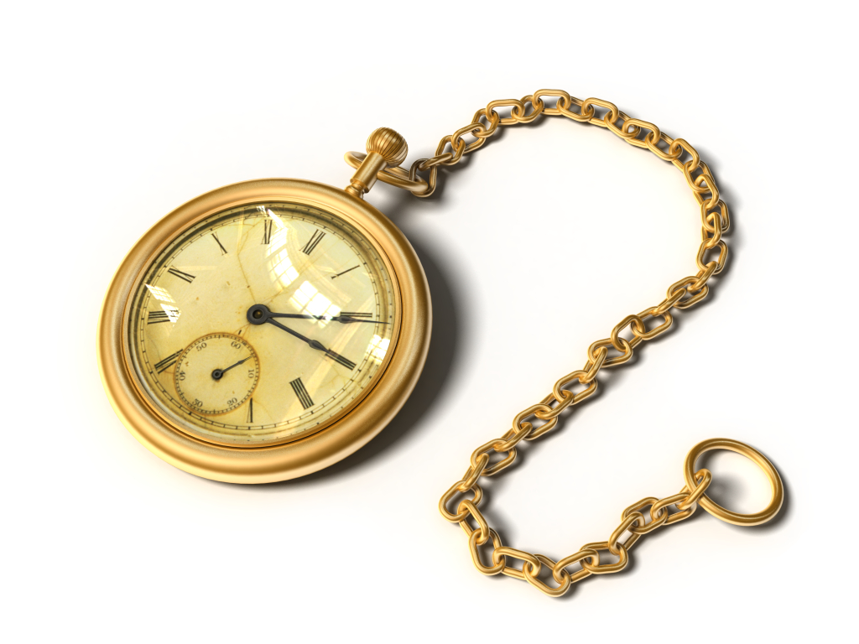

“The 11:59”
By Patricia C. McKissack

Lester Simmons was a thirty-year retired Pullman car porter—had his gold watch to prove it. “Keeps perfect train time,” he often bragged. “Good to the second.”

Daily he went down to the St. Louis Union Station and shined shoes to help supplement his meager twenty-four-dollar-a-month Pullman retirement check. He ate his evening meal at the porter house on Compton Avenue and hung around until late at night talking union, playing bid whist, and spinning yarns with those who were still “travelin’ men.” In this way Lester stayed in touch with the only family he’d known since 1920.

There was nothing the young porters liked more than listening to Lester tell true stories about the old days, during the founding of the Brotherhood of Sleeping Car Porters, the furst black union in the United States. He knew the president, A. Philip Randolph, personally, and proudly boasted that it was Randolph who’d signed him up as a union man back in 1926. He passed his original card around for inspection. “I knew all the founding brothers. Take Brother E. J. Bradley. We hunted many a day together, not for the sport of it but for something to eat. Those were hard times, starting up the union. But we hung in there so you youngsters might have the benefits you enjoy now.”
The rookie porters always like hearing about the thirteen-year struggle between the Brotherhood and the powerful Pullman Company, and how against all odds, the fledgling union had won recognition and better working conditions. Everybody enjoyed it too when Lester told tall tales about Daddy Joe, the porters’ larger-than-life hero. “Now y’all know the first thing a good Pullman man is expected to do is make up the top and lower berths for the passengers each night.”

“Come on, Lester,” one of his listeners chided. “You don’t need to describe our jobs for us.”

“Some of you, maybe not. But some of you, well—“ he said, looking over the top of his glasses and raising an eyebrow at a few of the younger porters. “I was just setting the stage.” He smiled good-naturedly and went on with his story. “They tell me Daddy Joe could walk flatfooted down the center of the coach and let down berths on both sides of the aisle.”

Hearty laughter filled the room, because everyone knew that to accomplish such a feat, Daddy Joe would have to have been superhuman. But that was it: To the men who worked the sleeping cars, Daddy Joe was no less a hero than Paul Bunyan was to the lumberjacks of the Northwestern forests.

“And when the 11:59 pulled up to his door, as big and strong as Daddy Joe was…” Lester continued solemnly. “Well, in the end even he couldn’t escape the 11:59.” The old storyteller eyed one of the rookie porters he knew had never heard the frightening tale about the porters’ Death Train. Lester took joy in mesmerizing his young listeners with all the details.

“Any porter who hears the whistle of the 11:59 has got exactly twenty-four hours to clear up earthly matters. He better be ready when the train comes the next night…” In his creakiest voice, Lester drove home the point. “All us porters go to board that train one day. Ain’t no way to escape the final ride on the 11:59.”

Silence.

“Lester,” a young porter asked, “you know anybody who ever heard the whistle of the 11:59 and lived to tell—“

“Not a living soul.”

Laughter.

“Well,” began one of the men, “wonder will we have to make up berths on that train?”

“If it’s an overnight trip to heaven, you can best be believing there’s bound to be a few of us making up the berths,” another answered.

“Shucks,” a card player stopped to put in. “They say even up in heaven we the ones gon’ be keeping all that gold and silver polished.”
“Speaking of gold and silver,” Lester said, remembering. “That reminds me of how I gave Tip Sampson his nickname. Y’all know Tip?”

There were plenty of nods and smiles.

The memory made Lester chuckle. He shifted in his seat to find a more comfortable spot. Then he began. “A woman got on board the Silver Arrow in Chicago going to Los Angeles. She was dripping in finery—had on all kinds of gold and diamond jewelry, carried twelve bags. Sampson knocked me down getting to wait on her, figuring she was sure for a big tip. That lady was worrisome! Ooowee! ‘Come do this. Go do that. Bring me this.’ Sampson was running over himself trying to keep that lady happy. When we reached L.A., my passengers all tipped me two or three dollars, as was customary back then.

“When Sampson’s Big Money lady got off, she reached into her purse and placed a dime in his outstretched hand. A dime! Can you imagine? Ow! You should have seen his face. And I didn’t make it no better. Never did let him forget it. I teased him so—went to calling him Tip, and the nickname stuck.”

Laughter

“I haven’t heard from ol’ Tip in a while. Anybody know anything?

“You haven’t go word, Lester? Tip boarded the 11:59 over in Kansas City about a month ago.”

“Sorry to hear that. That just leaves me and Willie Beavers, the last of the old, old-timers here in St. Louis.”

Lester looked at his watch—it was a little before midnight. The talkfest had lasted later than usual. He said his goodbyes and left, taking his usual route across the Eighteenth Street bridge behind the station.

In the darkness, Lester looked over the yard, picking out familiar shapes—the Hummingbird, the Zephyr. He’d worked on them both. Train travel wasn’t anything like it used to be in the old days—not since people had begun to ride airplanes. “Progress,” he scoffed. “Those contraptions will never take the place of a train. No sir!”

Suddenly he felt a sharp pain in his chest. At exactly the same moment he heard the mournful sound of a train whistle, which the wind seemed to carry from some faraway place. Ignoring his pain, Lester looked at the old station. He knew nothing was scheduled to come in or out till early morning. Nervously he lit a match to check the time. 11:59!

“No,” he said into the darkness. “I’m not ready. I’ve got plenty of living yet.”

Fear quickened his step. Reaching his small apartment, he hurried up the steps. His heart pounded in his ear, and his left arm tingled. He had an idea, and there wasn’t a moment to waste. But his own words haunted him. “Ain’t no way to escape the final ride on the 11:59.

“But I’m gon’ try!” Lester spent the rest of the night plotting his escape from fate.

“I won’t eat or drink anything all day,” he talked himself through his plan. “That way I can’t choke, die of food poisoning, or cause a cooking fire.”

Lester shut off the space heater to avoid an explosion, nailed shut all doors and windows to keep out intruders, and unplugged every electrical appliance. Good weather was predicted, but just in case a freak storm came and blew out a window, shooting deadly glass shards in his direction, he moved a straight-backed chair into a far corner, making sure nothing was overhead to fall on him.

“I’ll survive,” he said, smiling at the prospect of beating Death. “Won’t that be a wonderful story to tell at the porter house?” He rubbed his left arm. It felt numb again.

Lester sat silently in his chair all day, too afraid to move. At noon someone knocked on his door. He couldn’t answer it. Foot-steps…another knock. He didn’t answer.

A parad of minutes passed by, equally measured, one behind the other, ticking…ticking…away…The dull pain in his chest returned. He nervously checked his watch every few minutes.

Ticktock, ticktock.

Time had always been on his side. Now it was his enemy. Where had the years gone? Lester reviewed the thirty years he’d spent riding the rails. How different would his life have been if he’d married Louise Henderson and had a gallon of children? What if he’d taken that job at the mill down in Opelika? What if he’d followed his brother to Philly?

How different?

Ticktock, Ticktock.

So much living had passed so quickly. Lester decided if he had to do it all over again, he’d stand by his choices. His had been a good life. No regrets. No major changes for him.

Ticktock, Ticktock.

The times he’d had—both good and bad—what memories. His first and only love had been traveling, and she was a jealous companion. Wonder whatever happened to that girl up in Minneapolis? Thinking about her made him smile. Then he laughed. That girl must be close to seventy years old by now.

Ticktock, ticktock.

Daylight was fading quickly. Lester drifted off to sleep, then woke from a nightmare in which, like Jonah, he’d been swallowed by an enormous beast. Even awake he could still hear its heart beating…ticktock, ticktock…But then he realized he was hearing his own heartbeat.

Ticktock, ticktock.

Lester couldn’t see his watch, but he guessed no more than half an hour had passed. Sleep had overtaken him with suck little resistance. Would Death, that shapeless shadow, slip in that easily? Where was he lurking? Yea, though I walk through the valley of the shadow of death, I will fear no evil…The Twenty-third Psalm was the only prayer Lester knew, and he repeated it over and over, hoping it would comfort him.

Lester rubbed his tingling arm. He could hear the blood rushing past his ear and up the side of his head. He longed to know what time it was, but that meant he had to light a match—to risky. What if there was a gas leak? The match would set off an explosion. “I’m too smart for that, Death,” he said.

Ticktock, ticktock.

It was late. He could feel it. Stiffness seized his legs and made them tremble. How much longer? he wondered. Was he close to winning?

Then in the fearful silence he heard a train whistle. His ears strained to identify the sound, making sure it was a whistle. No mistake. It came again, the same as the night before. Lester answered it with a groan.

Ticktock, ticktock.

He could hear Time ticking away in his head. Gas leak or not, he had to see his watch. Striking a match, Lester quickly checked the time. 11:57.

Although there was no gas explosion, a tiny explosion erupted in his heart.

Ticktock, ticktock.

Just a little more time. The whistle sounded again. Closer than before. Lester struggled to move, but he felt fastened to the chair. Now he could hear the engine puffing, pulling a heavy load. It was hard for him to breathe, too, and the pain in his chest weighed heavier and heavier.

Ticktock, ticktock.

Time had run out! Lester’s mind reached for an explanation that made sense. But reason failed when a glowing phantom dressed in the porter’s blue uniform stepped out of the grayness of Lester’s confusion.

“It’s your time, good brother.” The specter spoke in a thousand familiar voices.

Freed of any restraint now, Lester stood, bathed in a peaceful calm that had its own glow. “Is that you, tip?” he asked, squinting to focus on this old friend standing in the strange light.

“It’s me, ol’ partner. Come to remind you that none of us can escape the last ride on the 11:59.”

“I know. I know,” Lester said, chuckling. “But man, I had to try.

Tip smiled. “I can dig it. So did I.”

“That’ll just leave Willie, won’t it?

“Not for long.”

“I’m ready.”

Lester saw the great beam of the single headlight and heard the deafening whistle blast one last time before the engine tore through the front of the apartment, shattering glass and splintering wood, collapsing everything in its path, including Lester’s heart.

When Lester didn’t show up at the shoeshine stand two days running, friends went over to his place and found him on the floor. His eyes were fixed on something quite amazing—his gold watch, stopped at exactly 11:59.

